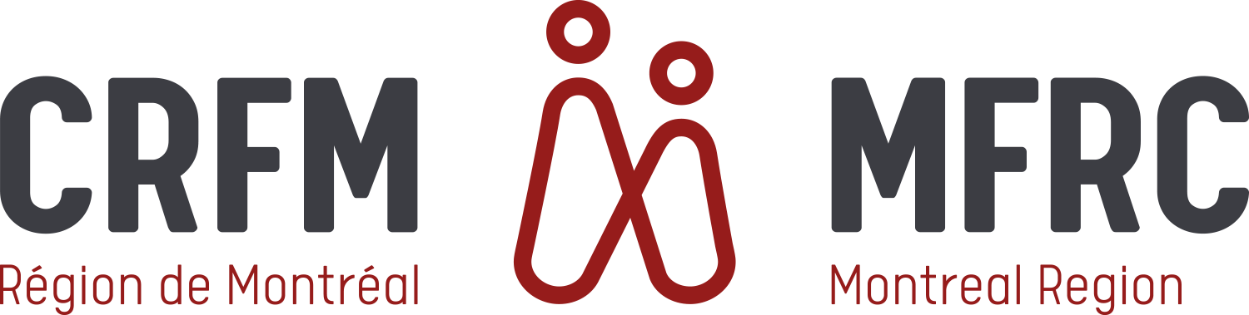

Information form - DAG
(Write in capitals letters)

SN: ______________ Rank: ________ First Name: ___________________ Last Name: __________________

No: _____ Street: __________________________ App# ______ Town: ______________________________

Prov: ___________ Postal Code: ___________ Telephone: Home: (____) ________________________

Cellular:(____)________________________
Spoken Language: French English
Military Status: Regular Reserve Unit: _______________________________
Civil status: Single Married Common law Separated/Divorced

Are you on imposed restriction? Yes No Are you on a course? Yes No

Email: __________________________________________________________
I have read the privacy notice and consent statement on the back, and I give my consent for myself and my dependent children: Yes  No 

Family - Spouse  Next of Kin  Relationship: ___________________

First Name: _______________________________ Last Name: _________________________________________

Address: as above  if different: ________________________________________________________________

Home e-mail address: ________________________________________________________________________

Phone: Cell: (____) ___________________________ Home: (____) _______________________

Work: (____) ___________________________ ext: ______________________________

Is your spouse/next of kin?
Language: French English
Military Status: Civilian  Military  Rank: _______ Service No.:__________________________

Regular Force  Reserve 

Children
Last name, first name Date of birth Age Language Lives with you
(d / m / y) same address
____________________________ ____________ ______ Fren  Eng  Yes  No 
____________________________ ____________ ______ Fren  Eng  Yes  No 
____________________________ ____________ ______ Fren  Eng  Yes  No 
____________________________ ____________ ______ Fren  Eng  Yes  No 
____________________________ ____________ ______ Fren  Eng  Yes  No 

Date of arrival of your family in the region? ________________________________________________

Would you like to receive our monthly newsletter? Yes  No 

The above information will be used only to send your family information about our programs, services and activities. This information is protected by the Protection of Personnel Information Privacy Code so you can be assured that all will be kept confidential. You have the right to access your information at any time, to have it amended or to have your name taken off of our mailing list.

Signature: ______________________________________________ Date: _______________________

Last update June 2023

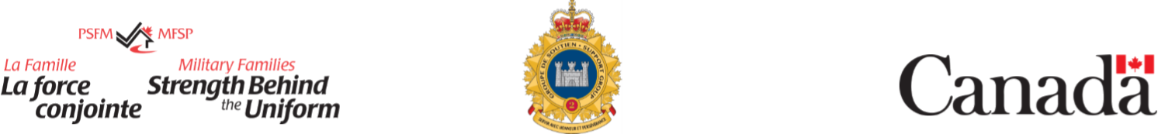

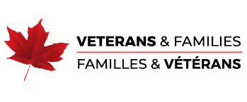

PRIVACY NOTICE AND CONSENT STATEMENT

All information and communications gathered is considered confidential and private. The Montreal region Military Family Resource Centre (MFRC) will take all possible safeguards to protect client information.

Personal information is collected pursuant to sections 2 and 38 – 41 of the National Defence Act. The information is used to administer the Military Family Services Program and the Veteran Family Program, which are managed by the Military Family Services (MFS), a division of the Canadian Forces Morale and Welfare Services (CFMWS) through local MFRCs. The personal information may include name, contact information, biographical information, date of birth (when required), identification number (partial military ID), physical attributes, signature, services provided during contact, opinions and views of, or about individuals.

The information may be used by the MFRC and/or MFS for reporting, audit, evaluation, and statistical purposes. In accordance with the memorandum of understanding between CFMWS and Veterans Affairs Canada (VAC), VFP user statistics will be provided to VAC for reporting on program performance indicators to Treasury Board of Canada Secretariat (TBS). Information is stored in Canada in a cloud-based case management system provided by Athena Software (service provider). Case file information may be transferred to a MFRC with the written consent of the individual. Information may also be used or disclosed for program mailing and outreach purposes.

In accordance with applicable laws, information may be disclosed in the following circumstances:

- Child protection – when the MFRC becomes aware of harm or potential harm to a child, it is required bylaw to report this to the local child welfare agency
- Harm to self or others – Professional Codes of Ethics and standards of Practice bind the MFRC to notifythe proper authorities if there is a reason to believe that there is potential for the client to harmthemselves or others
- Testimony in court – There are times when the MFRC may be requested by a court of law to discloseinformation obtained during sessions, under the above noted items

Personal information is protected, and only used and disclosed in accordance with the provisions of the Privacy Act (and other provincial/territorial privacy legislation applicable to the MFRC), as described above and in personal information bank CFMWS PPU 825 Military Family Services Program / Veteran Family Program. Under the Privacy Act, individuals have rights of access to and correction of their personal information, and the right to file a complaint to the Privacy Commissioner of Canada regarding the institution’s handling of personal information.

If you require clarification about this statement, contact our privacy coordinator at ATIP.AIPRP@cfmws.com. For more information on the Privacy Act, consult the Office of the Privacy Commissioner of Canada.

By signing, I certify that I understand, and consent to the collection, use and disclosure of my personal information as stated above.

Signature: ___________________________________________ Date: _____________________

